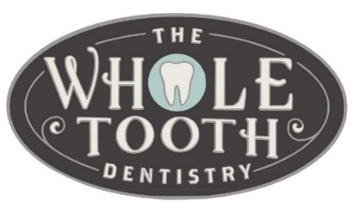
Post-operative Instructions: Implant Placement
SECOND DAY:
- You will likely still be swollen and have mild to moderate pain.
- Start a soft food diet (any food you can cut with a fork).
Continue drinking plenty of fluids.
- Continue oral hygiene similar to day 1.
- Take your medication as prescribed.
- Avoid vigorous activity that will elevate your heart rate.
The following instructions outline your day-by-day recovery
following implant placement.

FIRST DAY:
- On the car ride home, keep the gauze in your mouth that
we placed following surgery.
- When you get home, remove gauze and eat a small meal
THIRD & FOURTH DAY:
- You will likely still be swollen and have mild to no pain.
- Advance your diet as tolerated.
- You may start brushing with toothpaste, flossing and using over the counter mouth rinse. Continue to avoid
vigorous rinsing, sucking or spitting.
- Start using Chlorhexidine oral rinse.

and 2-3 glasses of water. Take your first dose of pain
medication and antibiotics (if given by your doctor) at this
time.
- Each meal should consist of bland, soft foods that do not
require chewing. Your lips and tongue will be numb and
can be traumatized by hot foods and vigorous chewing.
- Following your first meal, place a new damp piece of gauze
over the extraction sites only if there is continue bleeding.
If there is no bleeding, no gauze is needed.
FIFTH DAY
- Swelling may be present, but will be significantly
decreased. It may take up to 2 weeks for all the swelling to resolve.
- Return to normal diet and activity as tolerated.
- You should be eating 5-6 small meals per day and drinking
2-3 glasses of juice and/or water per hour. Example: Jello,
Ensure, Yogurt.
- Place ice over your cheeks and leave in place for 30 minutes,
then remove for 30 minutes, and then replace again. Continue
for the entire day.
- Get plenty of rest. Plan on resting with you head elevated on
AFTER THE 7th DAY
- Return to normal activity.
- You may feel a small metal protrusion or “cap” over where the implant was placed. This is normal and Dr. Ruby will let you know after the surgery whether you will feel the cap or not.
- Return after 2 weeks for your follow up visit as scheduled. Call our office at (912) 988-7723 if you have any questions or concerns following your surgery.

2-3 pillows.
- Place Vaseline on your lips if they are dry.
- Gently brush with warm water (avoid toothpaste) and rinse with
warm salt water. Do not SPIT-allow the rinse to drip out of your
mouth and then wipe off your lips.

